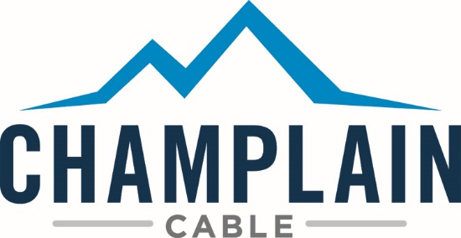
America’s premier innovator, designer and manufacturer of high-performance wire and cable with a 60-year history of providing solutions to the toughest problems in the world’s most extreme environments. We excel at developing customized products, utilizing our cross-linked irradiation technology, that meet power, signal and data transmission needs—no matter how demanding the challenge—while exceeding standards for quality, durability and safety.

Environmental Health & Safety Manager
The Corporate EHS Manager directs the organizations’ environmental and safety programs to minimize impacts to the environment, protect the safety of employees, and reduce risk and liability for the corporation. This will be accomplished by keeping abreast of regulatory requirements that impact the business, communicating those requirements to management, training employees, maintaining training files, performing incident investigations, and leading environmental and safety committees. Serves as the business’ ISO 14000 environmental management representative and maintains certification. Formulates work safety standards and enforces procedures. Risk prevention areas include hazardous material exposures, accidents, occupational injuries, fires, and other unsafe conditions. Must be 100% compliant with federal and state regulatory reporting requirements as well as national and international directives related to our products. Usually requires a 4 year degree, preferably in engineering or chemistry, plus 2-4 years relevant experience, or equivalent. ISO 9001/14001, basic OSHA and hazardous material and waste management experience a plus. Willingness to travel up to 15% of time.
Requirements are: 4 year degree, preferably in engineering or chemistry, plus 2-4 years relevant experience, or equivalent. ISO 9001/14001, basic OSHA, and hazardous material and waste management experience a plus. Willingness to travel up to 15% of time.
_____________________________________________________________________________________
We offer excellent wages, benefits, and are an EEO employer. Apply online at www.champcable.com/careers. No phone calls please

